CERTIFICATE OF AUTHENTICITY
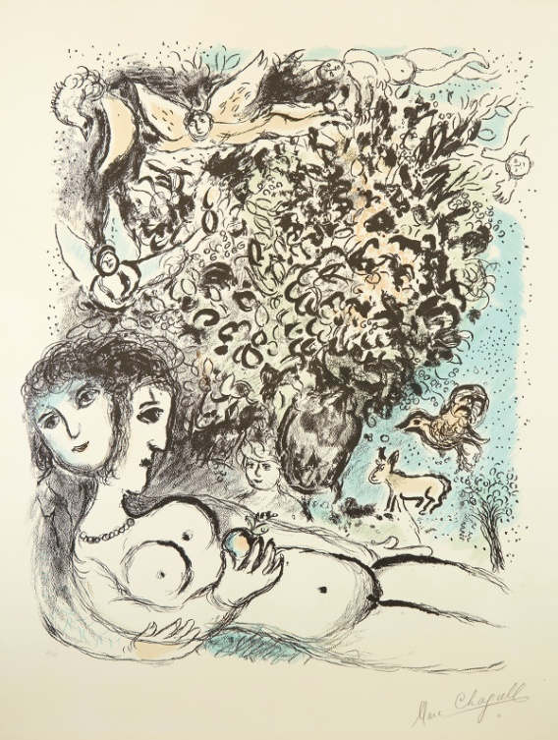
MARC CHAGALL (1887-1985)
Eve.
We hereby certify that this is an original Color Lithograph, 1971
750 x 620 mm; 29 1/2 x 24 1/2 inches, full margins.
Signed and numbered 20/50 in pencil, lower margin.
A very good impression.
Mourlot 636.

Prime Auctioneers, Inc.

14620 Keswick Street, Van Nuys, CA 91405 Tel: 818-778 6501 Fax: 818-778 6508

